DOCKER - 01
- Setup a virtual machine using Ubuntu image.
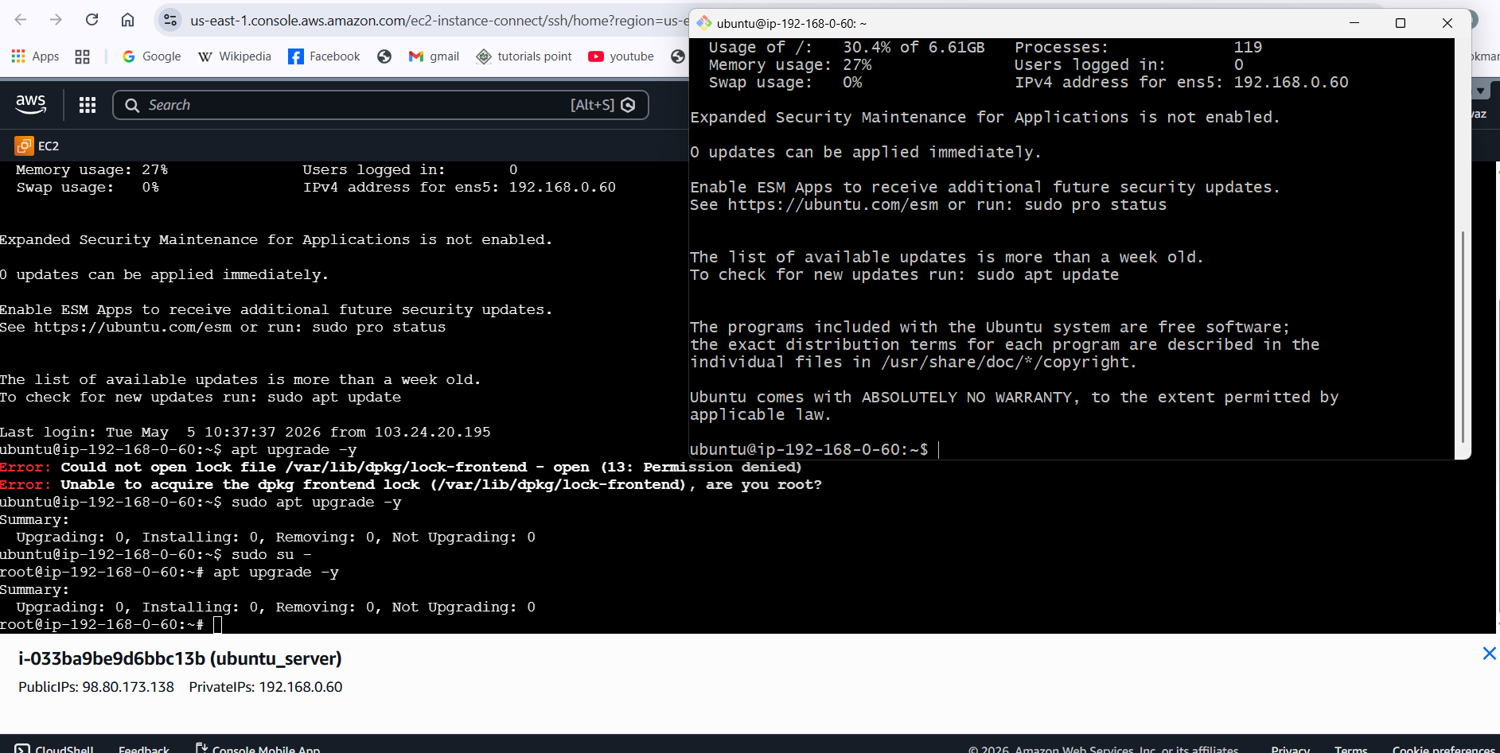
- Install docker on ec2.
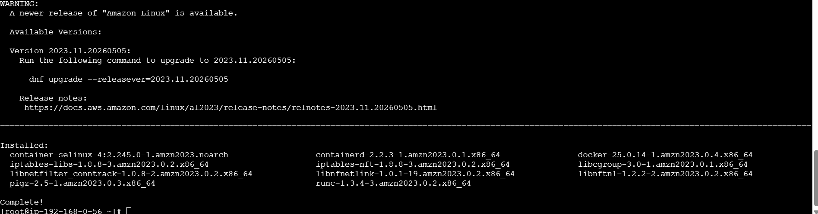
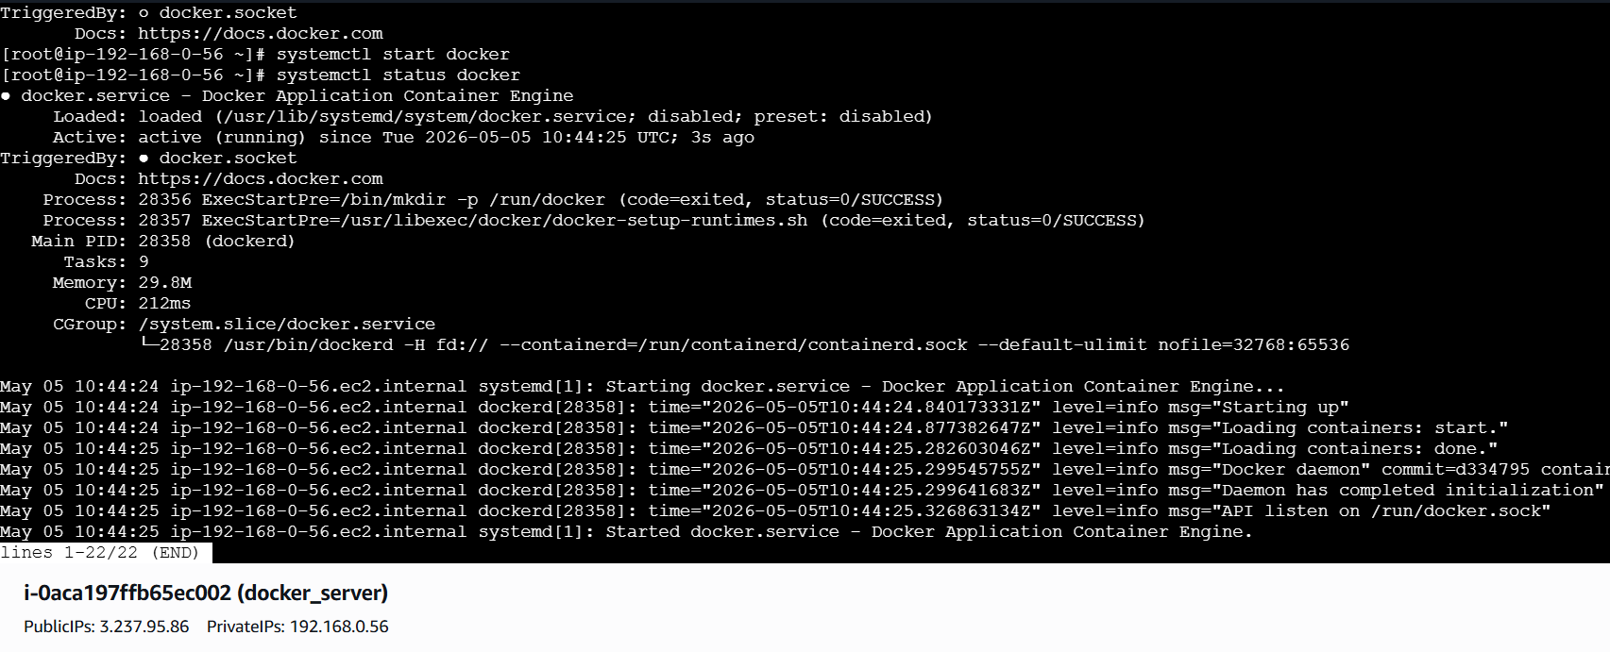
- Pull 5 docker images.(nginx,apache tomcat,ubuntu,jenkins,sonarqube)
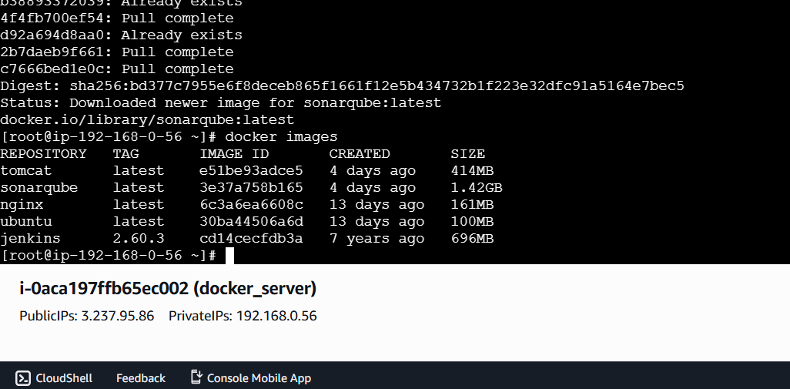
- Run nginx container and expose on port 81.
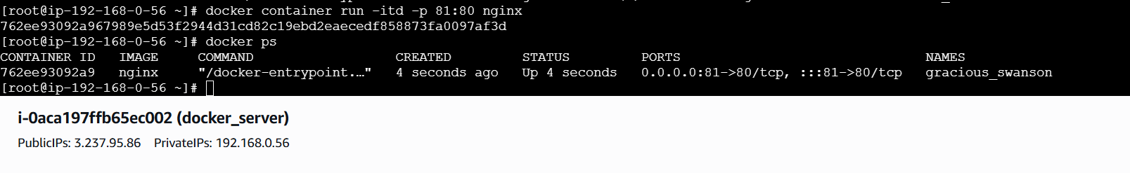
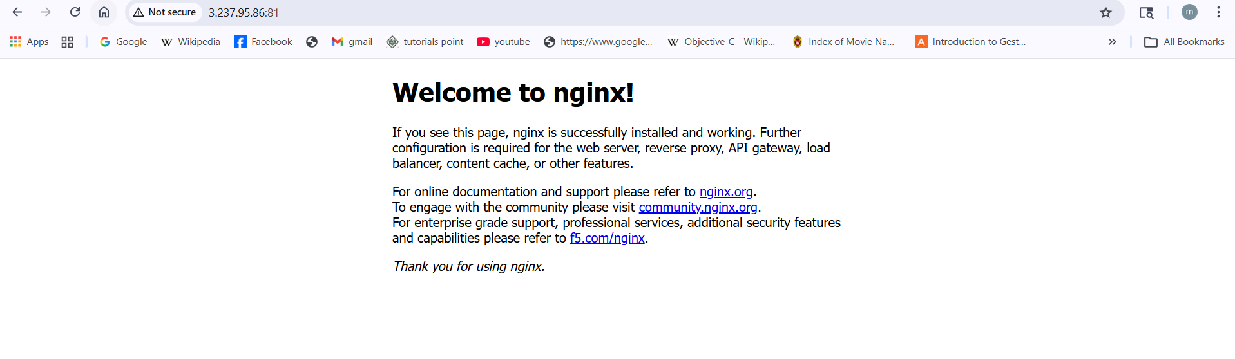
- Delete the apache tomcat image from local.
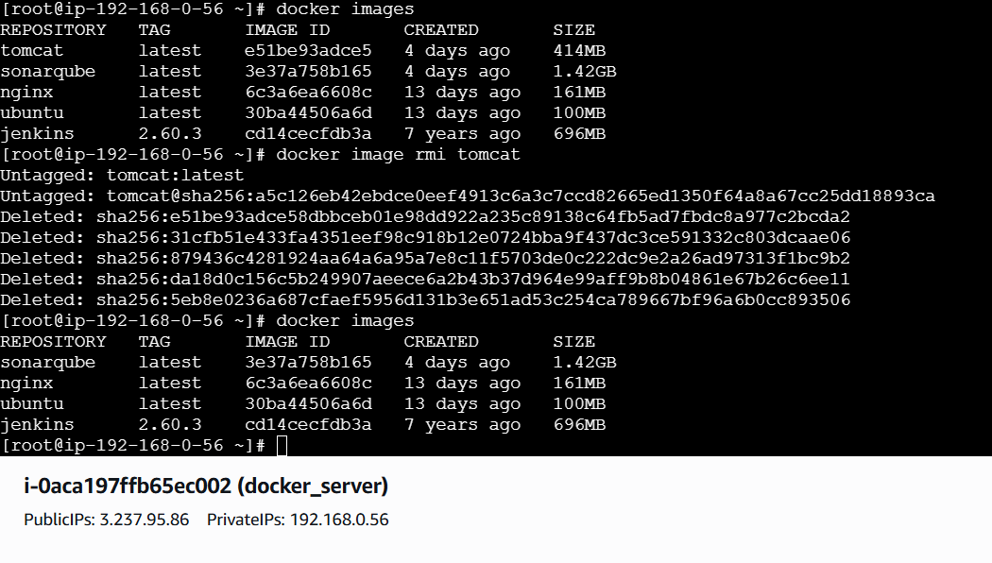
- Inspect the jenkins image,sonarqube image.
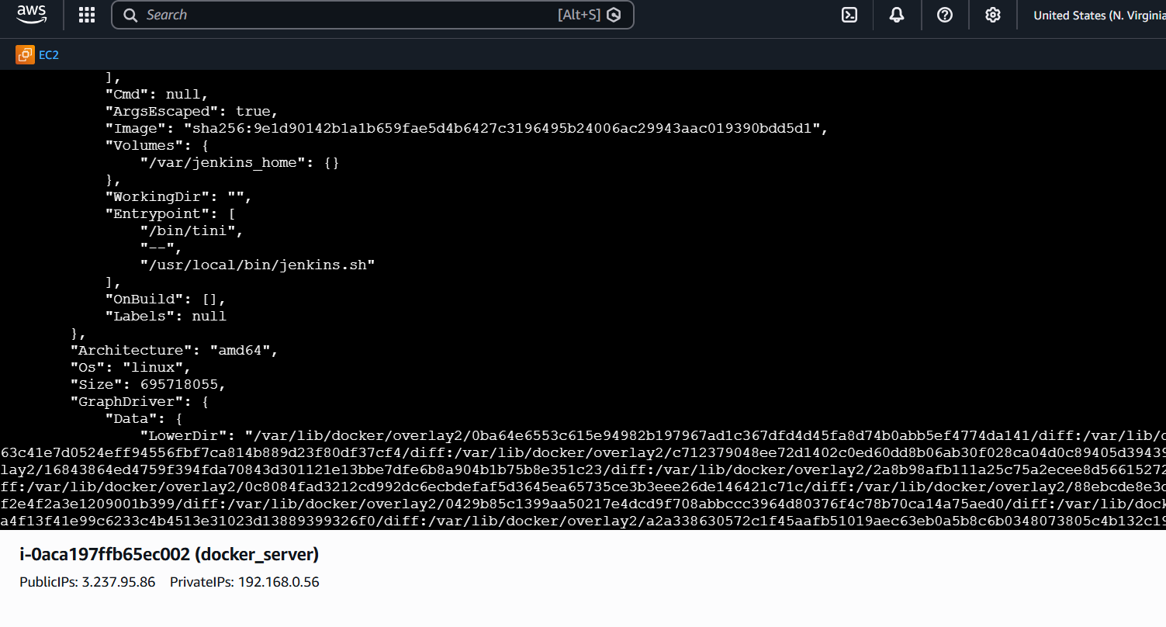
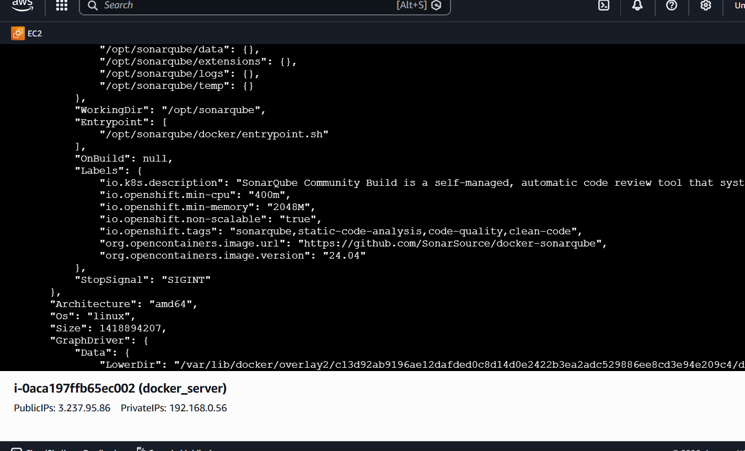
- Run jenkins contianer and run one sample job.
STEP 1: Run Jenkins Container
docker run -d -p 8080:8080 -p 50000:50000 --name jenkins \
jenkins/jenkins:lts
🔍 What this does:
• 8080 → Jenkins UI
• 50000 → Agent communication
• -d → Run in background
🌐 STEP 2: Access Jenkins in Browser
Open:
http://<your-ec2-ip>:8080
👉 Example:
http://13.61.15.150:8080
🚀 STEP 3: Get Initial Admin Password
Run:
docker exec jenkins cat /var/jenkins_home/secrets/initialAdminPassword
👉 Copy the password and paste into browser⚙️
STEP 4: Install Plugins
• Choose “Install Suggested Plugins”
• Wait for installation
🚀 STEP 5: Create Admin User
• Username: admin
• Password: (your choice)
• Save and continue🛠️
STEP 6: Create Sample Job
➤ Click:
Dashboard → New Item
➤ Enter:
• Name: test-job
• Select: Freestyle Project
• Click OK▶️
STEP 7: Configure Job
Scroll to Build Section:
• Click → Add build step
• Select → Execute shell
Add this command:
echo "Hello DevOps from Jenkins!"
Click Save▶️
STEP 8: Run Job
• Click Build Now
• Go to Build History
• Click build → Console Output
✅ Expected Output
Hello DevOps from Jenkins!
Finished: SUCCESS

